Assignment 1
BS6202

The file “assignment1_data.csv” accompanying this assignment describes the hospital admission rate in different facilities by gender over the period of 10 years in Singapore.

Name: Chen, Yaoding
Date of submission: 1Aug 2021

Table of Contents
Question 1 2
Question 2 3
Question 3 4
Question 4a 5
Question 4b 8

Question 1

- Identify the data type of the all the columns in “assignment1_data.csv” file

- year: ordinal/discrete numeric, depending on the question asked
- facility_type_a: categorical
- sex: categorical
- age: ordinal/categorical, depending on the question asked
- rate: continuous numeric

Question 2

- Calculate the mean and median of the hospital admission rate across different facilities and gender for each year between 2009 to 2019

If we treat each data point equally, then:

Year | Mean | Median
2009 | 54.05 | 2.9
2010 | 56.03 | 3.2
2011 | 58.05 | 3.05
2012 | 58.51 | 2.3
2013 | 58.71 | 2.25
2014 | 59.73 | 2.5
2015 | 59.82 | 2.75
2016 | 64.96 | 2.7
2017 | 66.19 | 2.75
2018 | 66.29 | 2.8
2019 | 67.61 | 2.8

Question 3

- Do you find any discrepancy between the mean and median values? If so, discuss the reasons this discrepancy.

Yes, the median of each year is always much larger than the mean of that year. This is because the distribution of the data is extremely uneven. Shortly speaking, both median and mean are measures of central tendency, but mean is less sensitive to data distribution and could be significantly away from median because of skewed distribution and/or outliers.

Specifically in our data, in each year, there are 10/18 of the data are below 5, and 6/18 of the data above 50. Take Year 2009 as an example, we make a histogram of the distribution of the data. It is apparent that the data is extremely right skewed. Most of the data fall within [0,10] bin, which makes the median value also within the range, but a lot of the data are much higher than 10, which pushes high the mean value to much higher than 10 (see the figure below).

Question 4a

- Based on the given data and the techniques, you learnt in your class, discuss if the following statements are True:

  - “Rate of adults admitted into psychiatry hospital and acute hospitals increases with time”

Partly True. Rationale:

Conclusions drawn from the summary of the summary data is actually not always correct. Below website shows all the source data: https://data.gov.sg/dataset/hospital-admission-rate-by-age-and-sex?view_id=50d36d2c-0099-471e-8445-db8cc03135de&resource_id=9f9ca3a2-0e0f-4e3c-bc23-a9b4533dabd2. In the website, it has been made clear that all the data has been normalised against every 1,000 resident population. Thus, we treat the data within each year during 2009-19 can be treated equally. Let’s assume adults means people from age groups of 15-64 years and people from 65 years & over.

Therefore, we can summarise our data as follows:

Year | Acute | Psychiatric Hospitals | Combined
2009 | 746.9 | 9.7 | 756.6
2010 | 772.9 | 10.2 | 783.1
2011 | 794.3 | 9.7 | 804
2012 | 795.5 | 7.7 | 803.2
2013 | 794.6 | 7.8 | 802.4
2014 | 798.5 | 8.2 | 806.7
2015 | 792.1 | 9 | 801.1
2016 | 850.9 | 8.8 | 859.7
2017 | 863.3 | 9 | 872.3
2018 | 858.6 | 8.8 | 867.4
2019 | 876.8 | 8.9 | 885.7

Statistically, Spearman rank correlation is a non-parametric test that is used to measure the degree of association between two variables, which is suitable to measure the monotonicity here. Then, we can use time and the admission rate as two parameters for testing monotonicity.

There are two ways to interpret “adults admitted into psychiatry hospital and acute hospitals”, which is about whether we regard “adults admitted into psychiatry hospital and acute hospitals” separately or as a whole.

For Acute Hospitals alone, r_{s} = 0.89091, p (2-tailed) = 0.00023. Thus, Psychiatric Hospitals admissions rate alone increases with time (to be exact, 2009-2019), although not always, which is consistent with our observation from the graph above.

For Psychiatric Hospitals alone, r_{s} = -0.33868, p (2-tailed) = 0.30829. Thus, Psychiatric Hospitals admissions rate alone does not increase with time (to be exact, 2009-2019), which is consistent with our observation from the graph above.

For Acute and Psychiatric Hospitals combined, r_{s} = 0.86364, p (2-tailed) = 0.00061 < 0.005. Thus, during 2009-19, the admissions rate of Acute and Psychiatric Hospitals combined did increase with time.

In summary, the admissions rate of Acute alone, and Acute and Psychiatric Hospitals combined significantly increases with time during 2009-19, yet there is no significant increase or decrease of admissions rate in Psychiatric Hospitals alone in the meanwhile.

However, whether this conclusion applies to longer period of time remains unclear, so we cannot firmly says that the admissions rate increases with time, since we are not sure what happened prior to after the time period. Also, it is crucial to point out we are not sure whether people going to acute hospitals also went to psychiatry hospital. In fact, it should be unsurprising that the two groups should share a number of patients. For example, some patients with severe psychological conditions are likely to hurt themselves and others, which may result in acute hospital admissions. Therefore, our data of Acute and Psychiatric Hospitals Combined could be overestimated. The real situation should be more complex than this.

Question 4b

- Based on the given data and the techniques, you learnt in your class, discuss if the following statements are True:

  - “Males have higher hospital admission rate than females”

Partly True. Rationale:

Below is a graph about our data from MoH. In this graph, it is quite clear that in 2009-2015, there is a pattern as follows: 1) there are more females admitted into acute hospitals; 2) there are more males admitted into psychiatric hospitals; 3) there are more females admitted into community hospitals; 4) overall, there are more females admitted into hospitals than males, which is contrary to the statement.
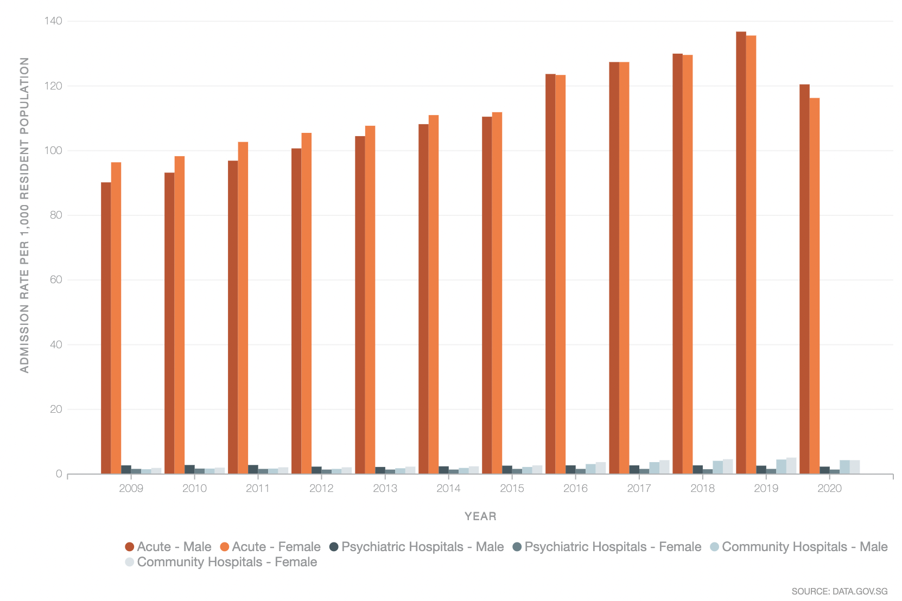
Interestingly, however, this pattern has changed a lot since 2016. 2019 and 2020 both have seen more male patients than females in acute and psychiatric hospitals. Especially in 2020, there are more male patients admitted in all hospital categories mentioned. Therefore, if we are talking about the general sex pattern of hospital admissions, the pattern is changing and we might not be able to predict the next change. At present, there are more males admitted, although it was not the case in the past and during most of the time.

